 | 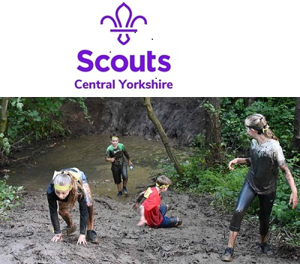

Information

Junior Warrior – Scout Event Only
Bramham Park – Friday 30TH June 2023

This event is for Beavers, Cubs, Scouts and Leaders – it is not a public event

It’s Bigger. It’s Better. It’s Muddier than ever before!

After a whopping 845 Beavers, Cubs, Scouts and Leaders completed the 2022 event, Junior Warrior returns in 2023 (having missed 2020 and 2021 ) for another amazing 3K – 15 obstacles course, packed with challenges for everyone!!

Suitable for big and little kids age 6 and over, you’ll all have a blast taking on “Muddy Mayhem”, “Canopy Climb” and Slideaway” to name a few. You will have to run, climb, jump, crawl and slide your way around 15 Challenge Obstacles.

Type of Activity:

Off-road obstacle course of approx. 3.KM in length, featuring 15 tailor-made obstacles, including walls, pipes, nets, loads of mud and an awesome water slide! The course is suitable for adults as well as children.

Event Details:

Location: Bramham Park (postcode LS23 6LT)
Arrival Time: from 5.30pm, First Wave: from 6.00pm
Cost: £15 for Beavers, Cubs & Scouts – Leaders are free (limited numbers per group)

There will be staggered start times – which will be advised to group leaders nearer the time.

Beavers, Cubs and Scouts will have different start times so that everybody on the course at any given time will be of a similar age.

When not on the course young people will be able to spectate and participate in other games and activities.

Please note there is ample car parking on site, please just follow the signs from the Terry Lug entrance. Access will be signposted.

Families are encouraged to come and support the Junior Warriors.

The course will start and finish adjacent to the car parks and main Event Village in Bramham Park Estate, so navigation on the evening will be straightforward. The course will be for Beavers, Cubs Scouts and Leaders only, but many parts will be easily accessible for spectators and group leaders. (Please note that the event is primarily for U18s – It is not a leader’s event and your group booking numbers should reflect this. Any bookings showing an excessive number of adults will be returned to you.)

Volunteers and outdoor trained lifeguards (where relevant) will be on each obstacle, and volunteers will be distributed to ensure they have eyes on every section of the course.

Refreshments will be available to purchase from the Event Village by Total Warrior Caterers.

The event is limited to 850 participants on a first come first served basis – so don’t delay! On receipt of your group booking form an invoice will be sent to secure your booking.

Information on the Event Organisers:

Total Warrior are a professional events delivery company, putting on events across the country since 2011. They are returning to Leeds in 2021 and are expecting over 10,000 people to join them at Bramham Park over the weekend.

In an effort to build on the success of previous years and maintain Total Warrior’s reputation as an epic adventure for all the family, the team don’t want young people stuck on the side-lines this year; they want them getting stuck in.

Expectation of fitness levels and clothing:

Junior Warrior is not a race, nor is it compulsory to complete each obstacle. Junior Warriors can complete the course in their own time, walking and resting where necessary, and can simply bypass an obstacle should they not wish to complete it.

In terms of clothing, young people will need to wear sports gear that they are comfortable getting wet and muddy, including trainers. It would also be worth bringing an old towel to clean off with post event. Male and Female changing facilities are available, but showers are not. A change of clothes would also be advisable.

Remember - we will be outside so wet weather clothing may be required.

Medical Information

All Young People will need a completed Health Form sent to the County Office by Friday 2nd June 2023. The Medical Contractor for this event is St John’s Ambulance.

Course Map 2019

